

BIT 4107 – Mobile Application Development
ENHANCED PROFESSIONAL STUDENT LOGBOOK
Student Name: SHEILA WAITHERA MURIITHI
Admission Number: BIT/2024/32455
Academic Year: YEAR 4
Semester:SEM II
Lecturer:Mr.Nyoro

Table of Contents
Drug lookup action 3
The drug search page 4
Filtered search of certain drug 5
Tools used; 5
Personal reflection; 5

WEEK 5 ASSIGNMENT
Assignment
Develop a Mobile API Consumer Application that connects to a public REST API and displays records.

Drug lookup action
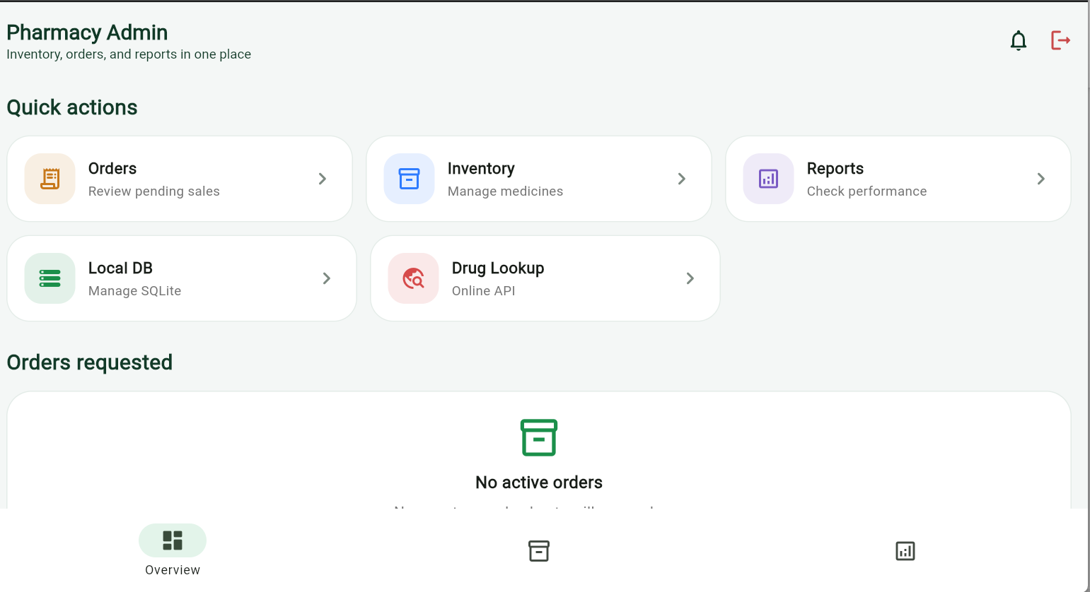

The drug search page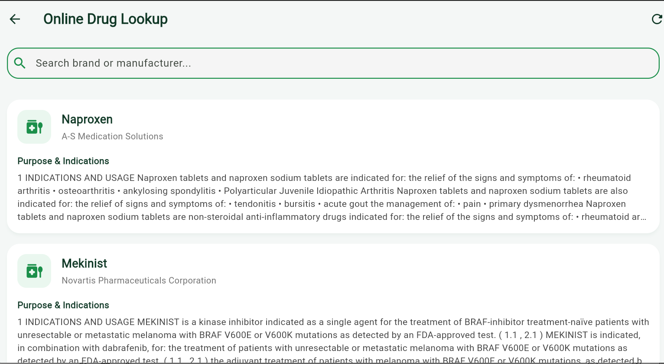

Filtered search of certain drug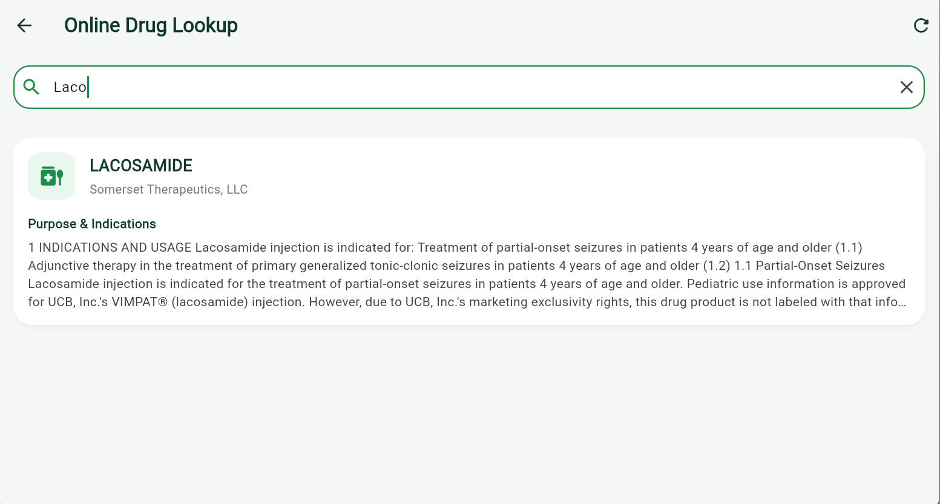

Tools used;
- Flutter & Dart: The core framework and programming language used to build the cross-platform UI and application logic.
- REST API (http package): Used to connect to and consume the public openFDA API (https://api.fda.gov) for the live drug lookup feature.

Personal reflection;
Developing this application provided valuable hands-on experience in bridging local databases with external REST APIs. Combining an offline-first SQLite architecture with live FDA API data fetching highlighted the importance of robust state management and seamless asynchronous data handling to create a responsive, real-world user experience.

